# Assignment I

**Data Communication CS3CO28**

* 1. What is the difference between connection-less and connection-oriented services?

Ans. Connection-oriented and Connection-less Services are used to establish connections between two or more devices.

## **Connection-oriented Services**

Connection-oriented Services, are similar to telephone system where parties use handshake method to establish connection between sender and receiver. These services include connection establishment and connection termination.

## **Connection-less Services**

Connection-less Services, are similar to postal system where packets moves from one party to another without establishing a connection first. These services do not include connection establishment and connection termination.

Following are the important differences between Connection-oriented and Connection-less Services.

| Sr. No. | Key | Connection-oriented Services | Connection-less Services |
| --- | --- | --- | --- |
| 1 | Analogy | Connection-oriented Services are similar to Telephone System. | Connection-less Services are similar to Postal System. |
| 2 | Usage | Connection-oriented Services are used in long and steady communication networks. | Connection-less Services are used in volatile networks. |
| 3 | Congestion | No Congestion in Connection-oriented Service. | Congestion is quiet possible in Connection-less Services. |
| 4 | Reliablility | Connection-oriented Service are highly reliable. | In Connection-less Services, no guarantee of reliablity. |
| 5 | Packet Routing | In Connection-oriented Service, packets follows same route. | In Connection-less Services, packets can follow any route. |

* 1. Define fragmentation and explain why the IPv4 and IPv6 protocols need to fragment some packets. Is there any difference between the two protocols in this matter?

Ans. IP fragmentation is an Internet Protocol (IP) process that breaks packets into smaller pieces (fragments), so that the resulting pieces can pass through a link with a smaller maximum transmission unit (MTU) than the original packet size.

With the new protocol, fragmentation is managed at the ends by means of a special extension header.

More specifically, there are two main differences: Difference one is the fields for handling fragmentation are not in the basic IPv6 header but are put into an extension header if fragmentation is required. This makes IPv6 fragmentation lean because this fragmentation extension header is only inserted in the packet, if fragmentation needs to be done. Difference two is that IPv6 routers do not fragment anymore. Fragmentation has to be done by the source host.

* 1. Describe OSI Model.

Ans. The Open Systems Interconnection (OSI) model is a conceptual model created by the International Organization for Standardization which enables diverse communication systems to communicate using standard protocols. In plain English, the OSI provides a standard for different computer systems to be able to communicate with each other.

The OSI model can be seen as a universal language for computer networking. It’s based on the concept of splitting up a communication system into seven abstract layers, each one stacked upon the last.

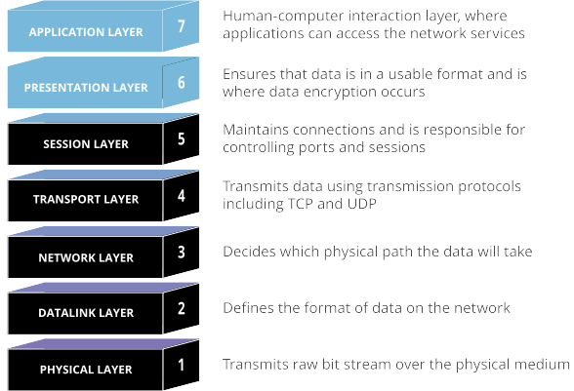

In order for human-readable information to be transferred over a network from one device to another, the data must travel down the seven layers of the OSI model on the sending device and then travel up the seven layers on the receiving end.

* 1. Describe TCP IP Model.

Ans. TCP/IP Reference Model is a four-layered suite of communication protocols. It was developed by the DoD (Department of Defence) in the 1960s. It is named after the two main protocols that are used in the model, namely, TCP and IP. TCP stands for Transmission Control Protocol and IP stands for Internet Protocol.

The four layers in the TCP/IP protocol suite are −

**Host-to- Network Layer** −It is the lowest layer that is concerned with the physical transmission of data. TCP/IP does not specifically define any protocol here but supports all the standard protocols.

**Internet Layer** −It defines the protocols for logical transmission of data over the network. The main protocol in this layer is Internet Protocol (IP) and it is supported by the protocols ICMP, IGMP, RARP, and ARP.

**Transport Layer** − It is responsible for error-free end-to-end delivery of data. The protocols defined here are Transmission Control Protocol (TCP) and User Datagram Protocol (UDP).

**Application Layer** − This is the topmost layer and defines the interface of host programs with the transport layer services. This layer includes all high-level protocols like Telnet, DNS, HTTP, FTP, SMTP, etc.

The following diagram shows the layers and the protocols in each of the layers −

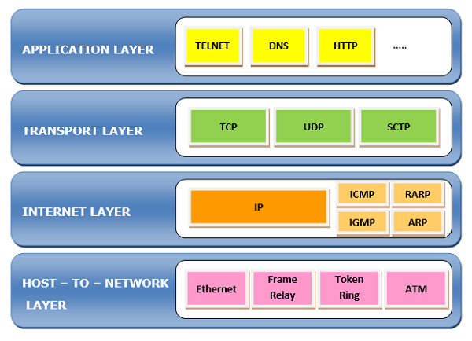

* 1. What is the difference between a port address, a logical address, and a physical address?

Ans. Through logical address the system identify a network (source to destination). after identifying the network physical address is used to identify the host on that network. The port address is used to identify the particular application running on the destination machine.

**Logical Address**: An IP address of the system is called logical address. This address is the combination of Net ID and Host ID. This address is used by network layer to identify a particular network (source to destination) among the networks. This address can be changed by changing the host position on the network. So it is called logical address.

**Physical address**: Each system having a NIC(Network Interface Card) through which two systems physically connected with each other with cables. The address of the NIC is called Physical address or mac address. This is specified by the mmanufacturer company of the card. This address is used by data link layer.

**Port Address**: There are many application running on the computer. Each application run with a port no.(logically) on the computer. This port no. for application is decided by the Kernal of the OS. This port no. is called port address.